**Glomeruli Detection using Transfer Learning**

**(For Windows users)**

1. Install tensor and all other dependencies:

pip install pillow

pip install lxml

pip install jupyter

pip install matplotlib

pip install tensorflow==1.15

1. Open Git Bash, check the current directory with “pwd”. If this is where you would like to clone the repository. I created a folder C:/Users/*your-username*/tensorflow. Then use the following to clone on command prompt:

git clone <https://github.com/tensorflow/models> (for tensor flow version 1.15, but other version 1.x are also compatible)

1. For object detection , we need to install several object detection api’s available in tensor flow like:[https://github.com/cocodataset/cocoapi.git](https://github.com/cocodataset/cocoapi.git%20)
   1. For coco api use the following command

git clone [https://github.com/cocodataset/cocoapi.git](https://github.com/cocodataset/cocoapi.git%20)

* 1. Download proto buff from the link <https://github.com/protocolbuffers/protobuf/releases>

protoc-3.11.4-win64.zip

* 1. Place the extracted files from zip folder in ../Tensorflow/models/research/object_detection
  2. Go to ../Tensorflow/models/research and run following command prompt folder

"../Tensorflow/models/research/object_detection/bin/protoc.exe" object_detection/protos/*.proto --python_out=.

1. Open ../Tensorflow/models/research/object_detection/object_detection_tutorial.ipynb and run it to see whether object detection model is working or not
2. Download labeller for glomeruli detection using the link <https://tzutalin.github.io/labelImg/>. It is the GUI version.  
   For python version, you can visit <https://github.com/tzutalin/labelImg>
   1. Open the directory containing cell images using labelImg.  
        
      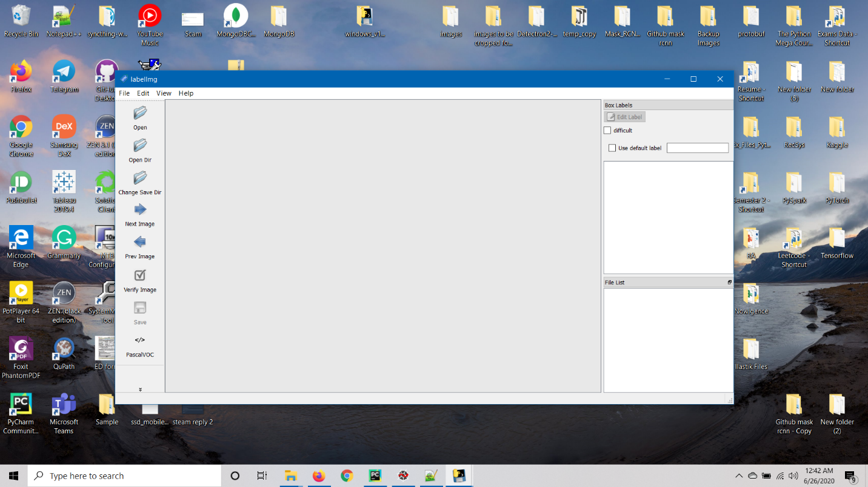
   2. Choose the directory containing the images  
      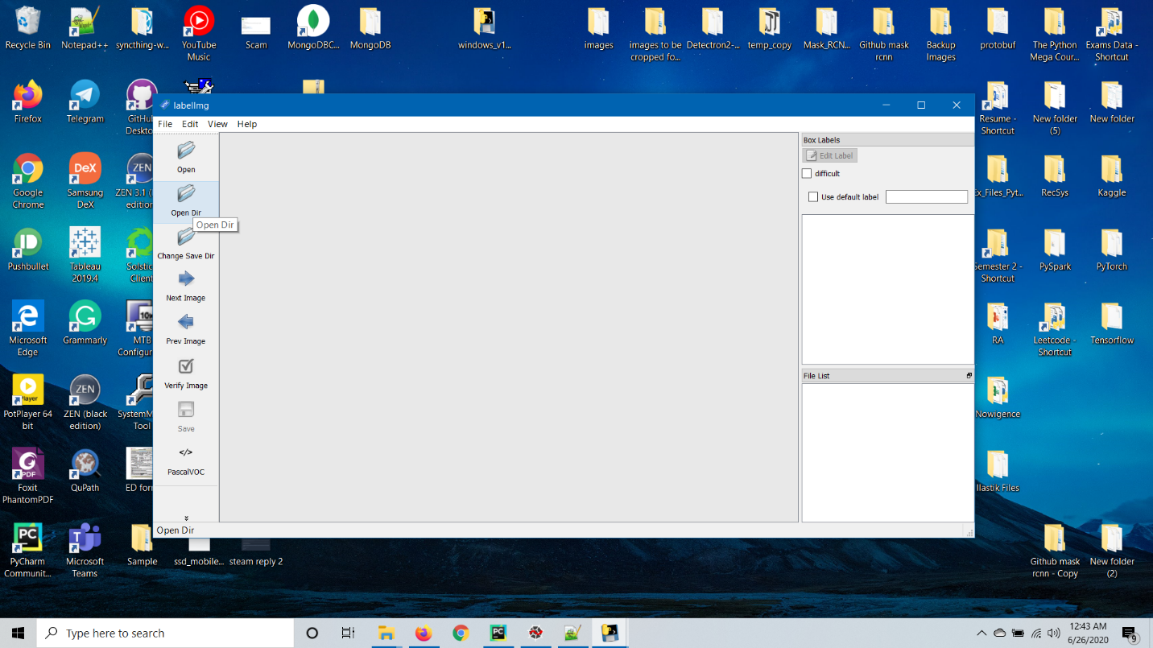  
      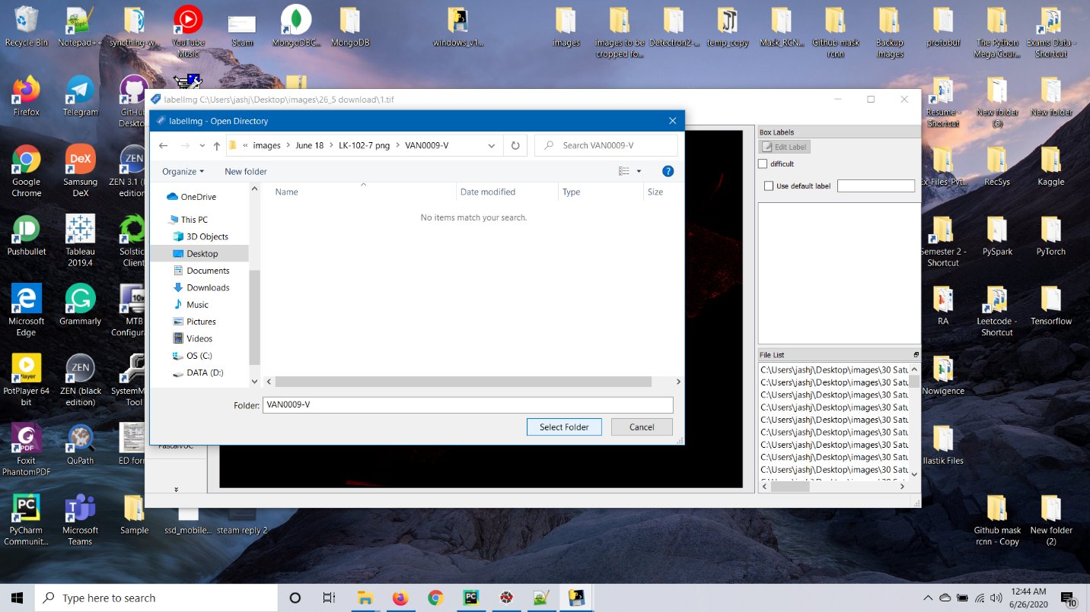
   3. Create RectBox over the glomeruli by dragging over the region.  
      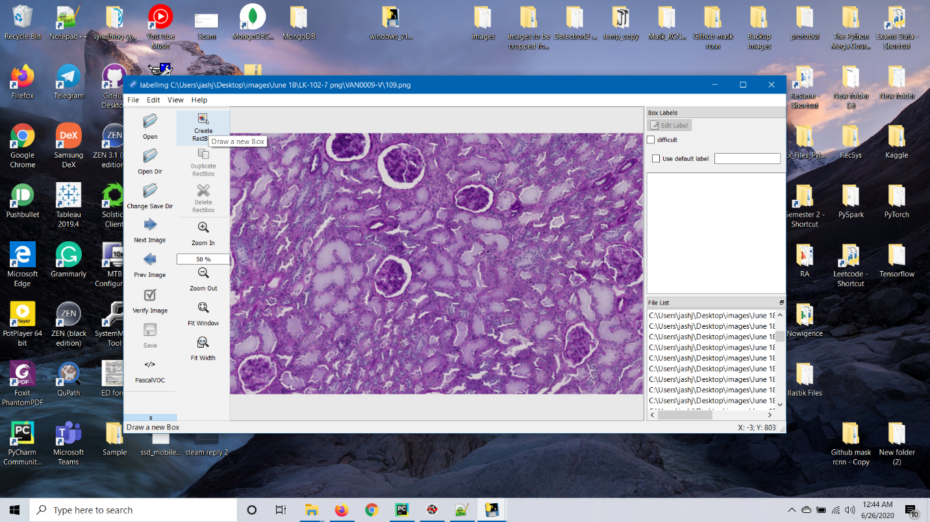  
        
      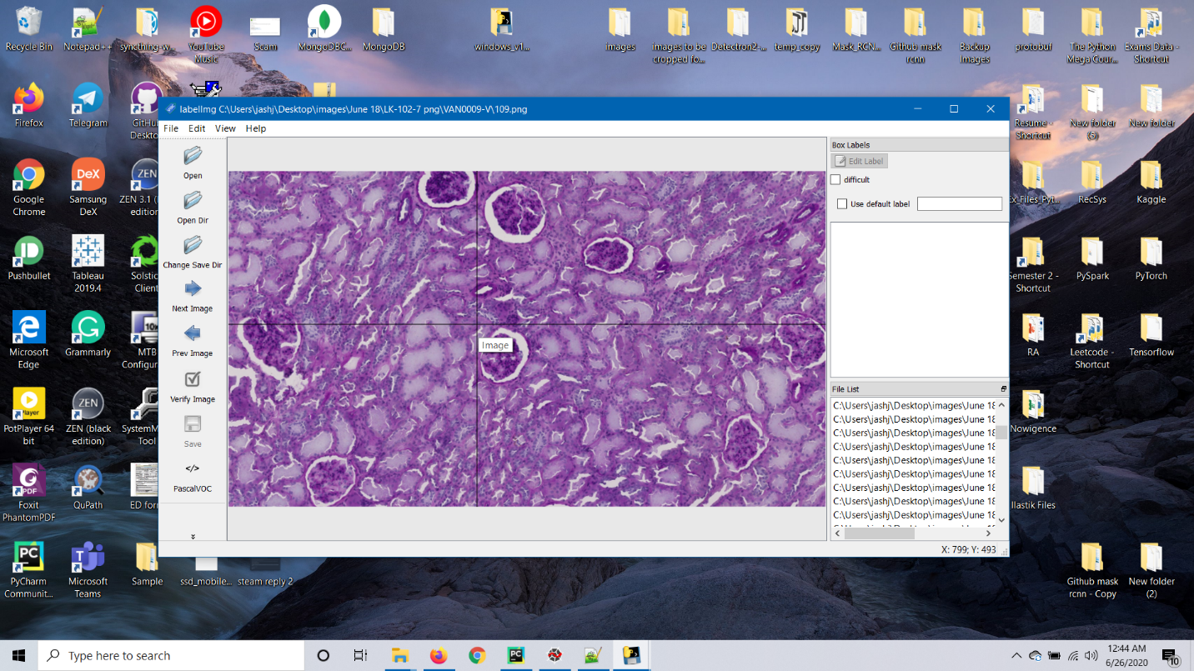
   4. Set the label as ‘Glomeruli’.  
      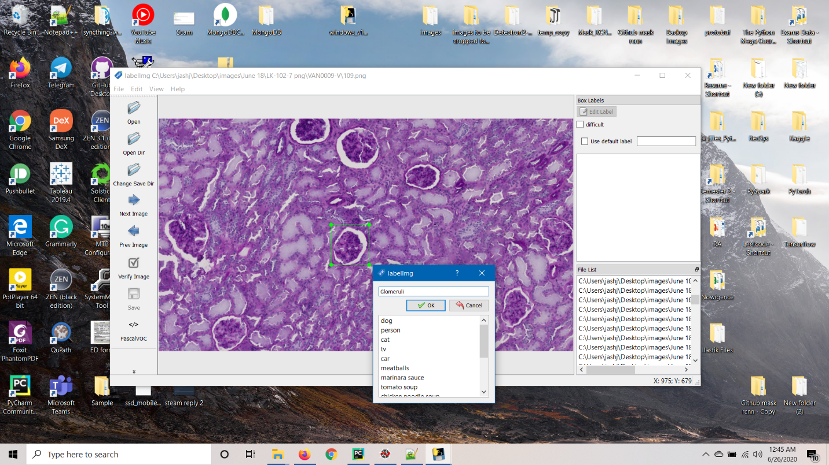  
        
        
      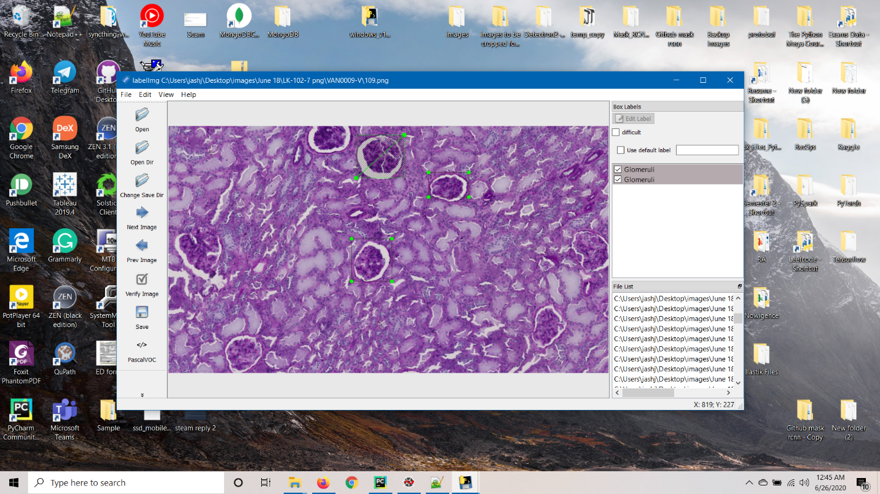
   5. Click on save to set save the annotations in an XML file.  
      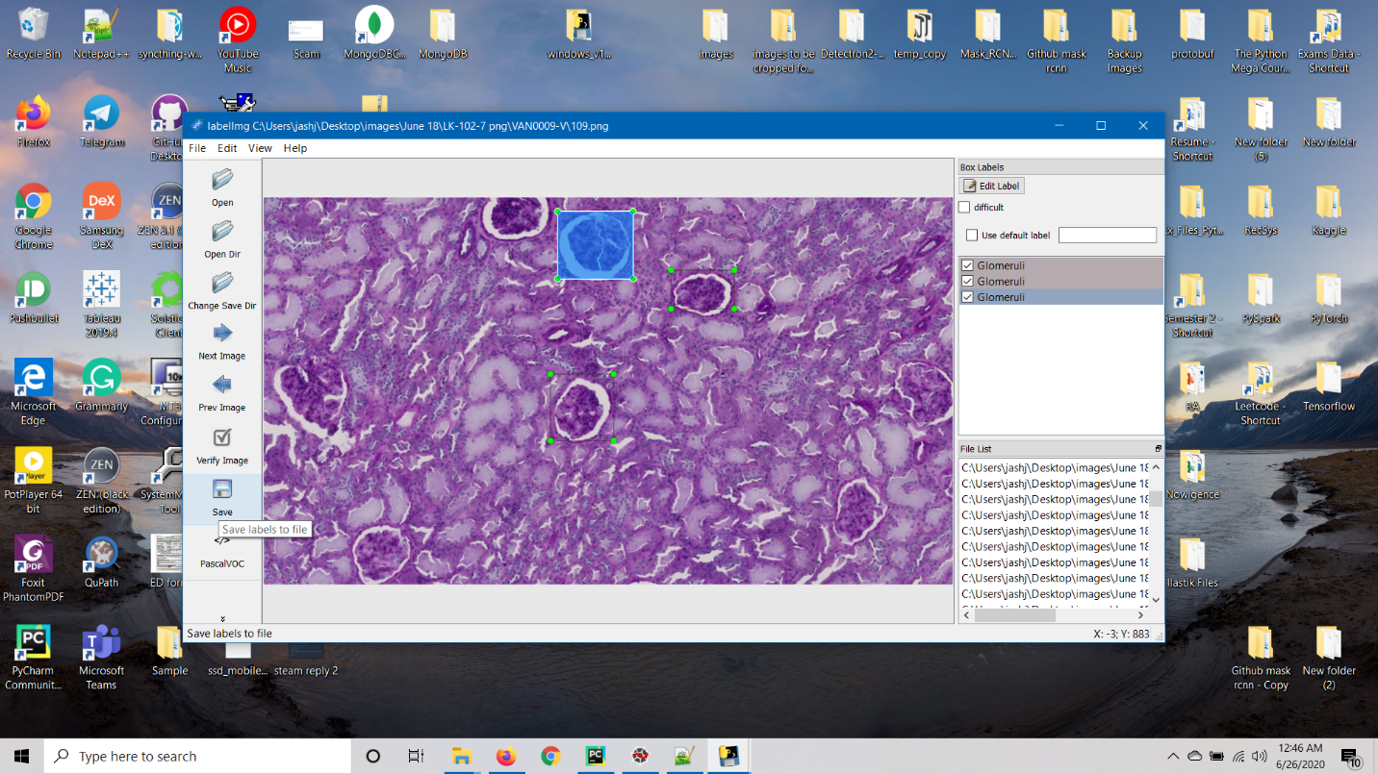  
        
        
        
      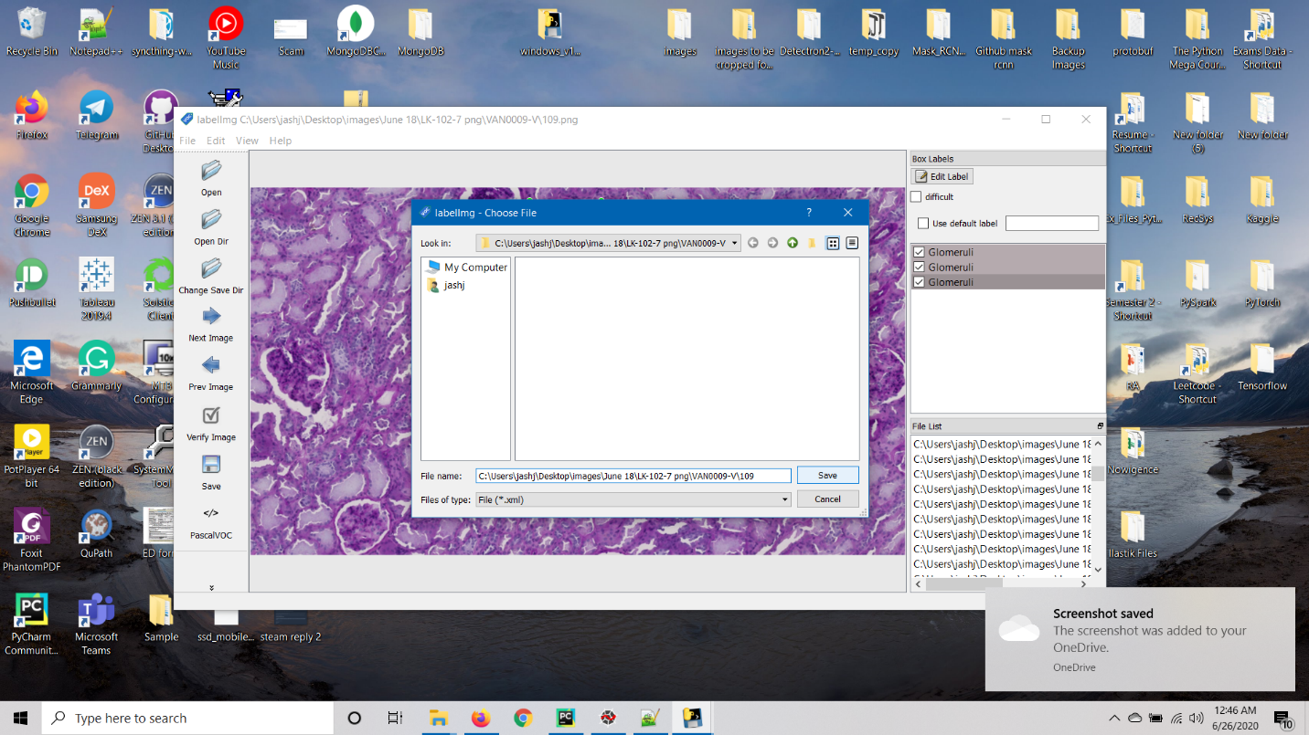
   6. Create a new folder(images) containing test and train images in ../Tensorflow/models/research/object_detection
   7. Save the images in the folder ../Tensorflow/models/research/object_detection/images/train_images  
      ../Tensorflow/models/research/object_detection/images/test_images  
      Keep some of the images (.jpg) on test_images folder as well which you want to test your model
   8. Keep the .jpg in the same folder as .xml file.
3. Run xml_to_csv.py file from the folder ../Tensorflow/models/research/object_detection  
   (file provided. Might need to change the directory in the file)
4. Run generate_tfrecord.py from the folder ../Tensorflow/models/research/object_detection  
   (file provided. Might need to change the directory in the file)  
     
   Command for train files:  
   python generate_tfrecord.py --csv_input=images\train_labels.csv --image_dir=images\train --output_path=train.record

Command for testfiles:  
python generate_tfrecord.py --csv_input=images\test_labels.csv --image_dir=images\test --output_path=test.record

1. Create folder ‘training’ in the object_detection folder with the following two files. Labelmap and [faster_rcnn_inception_v2_pets.config](http://faster_rcnn_inception_v2_pets.config) (Files provided)  
   These files are a custom label map for Glomeruli and a training configuration file. ()  
   Note: Edit the location of the folders in the respective places  
   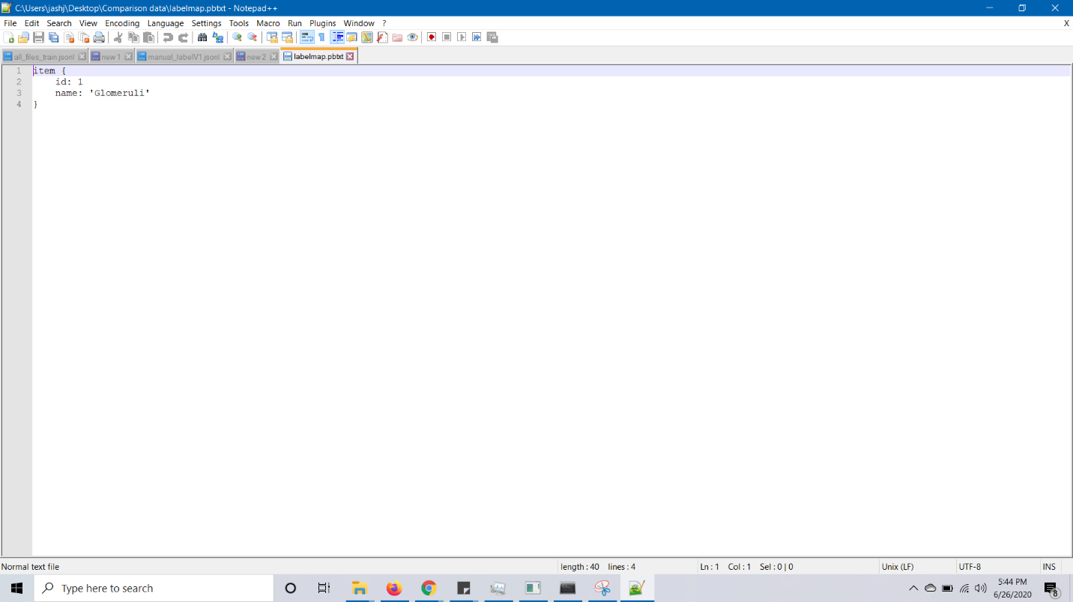
2. From the following link:  
   <https://github.com/tensorflow/models/blob/master/research/object_detection/g3doc/detection_model_zoo.md>  
   download the following file : faster_rcnn_inception_v2_coco.  
   and keep it in the object_detection folder after extracting it.   
   You can choose other weights also. If, you select different weights, then change the names in the following steps accordingly.
3. Extract the folder into ‘../Tensorflow/models/research/object_detection’ folder.  
   Note: After the extraction, the folder named will be faster_rcnn_inception_v2_coco_2018_01_28 (or it can be a later version also).

It has the frozen inference graph and the model files.

1. Edit the [faster_rcnn_inception_v2_pets.config](http://faster_rcnn_inception_v2_pets.config) file accordingly and enter the correct filepaths. Refer to the screenshot below.  
   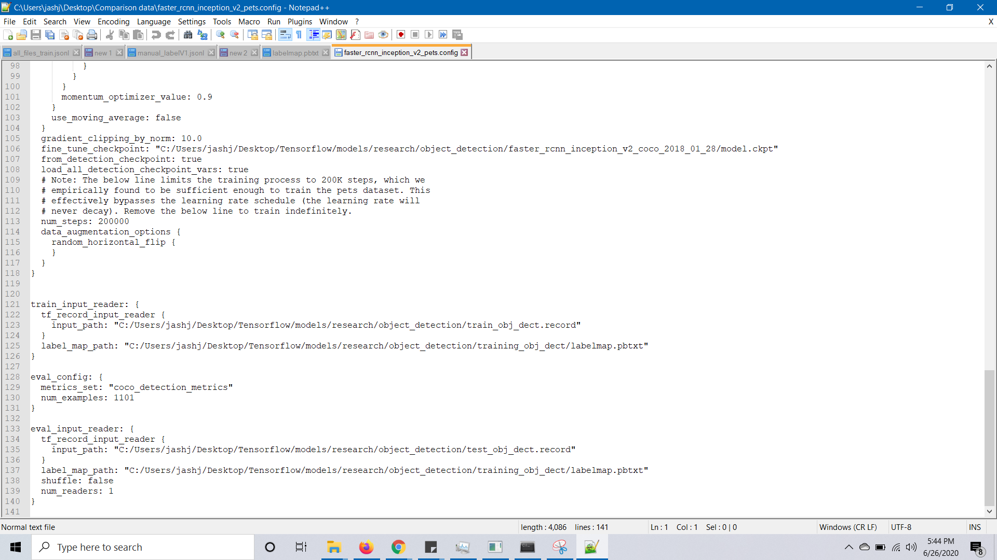
2. Add ‘../Tensorflow/models/research ’ and ‘../Tensorflow/models/research/slim’ folder to PYTHONPATH.
3. From the object_detection folder, run the following command  
   python model_main.py --logtostderr --model_dir=training/ --pipeline_config_path=training/faster_rcnn_inception_v2_pets.config
4. After the training starts, you can see the metrics using tensorboard.  
   From the object_detection folder, run the following command   
   tensorboard --logdir=training

This will open a localhost webpage. If this doesnot happen automatically, run localhost:6006 in Google Chrome.

1. After you are satisfied with the training loss, interrupt the model using Ctrl+C.
2. In the same command window, run the following command:  
     
   python export_inference_graph.py --input_type image_tensor --pipeline_config_path training/faster_rcnn_inception_v2_pets.config --trained_checkpoint_prefix training/model.ckpt-2425 --output_directory inference_graph  
     
   Note: The 2425 refers to the last epoch number before the model was freezed. This can be different in your case. Refer to the below screenshot.  
   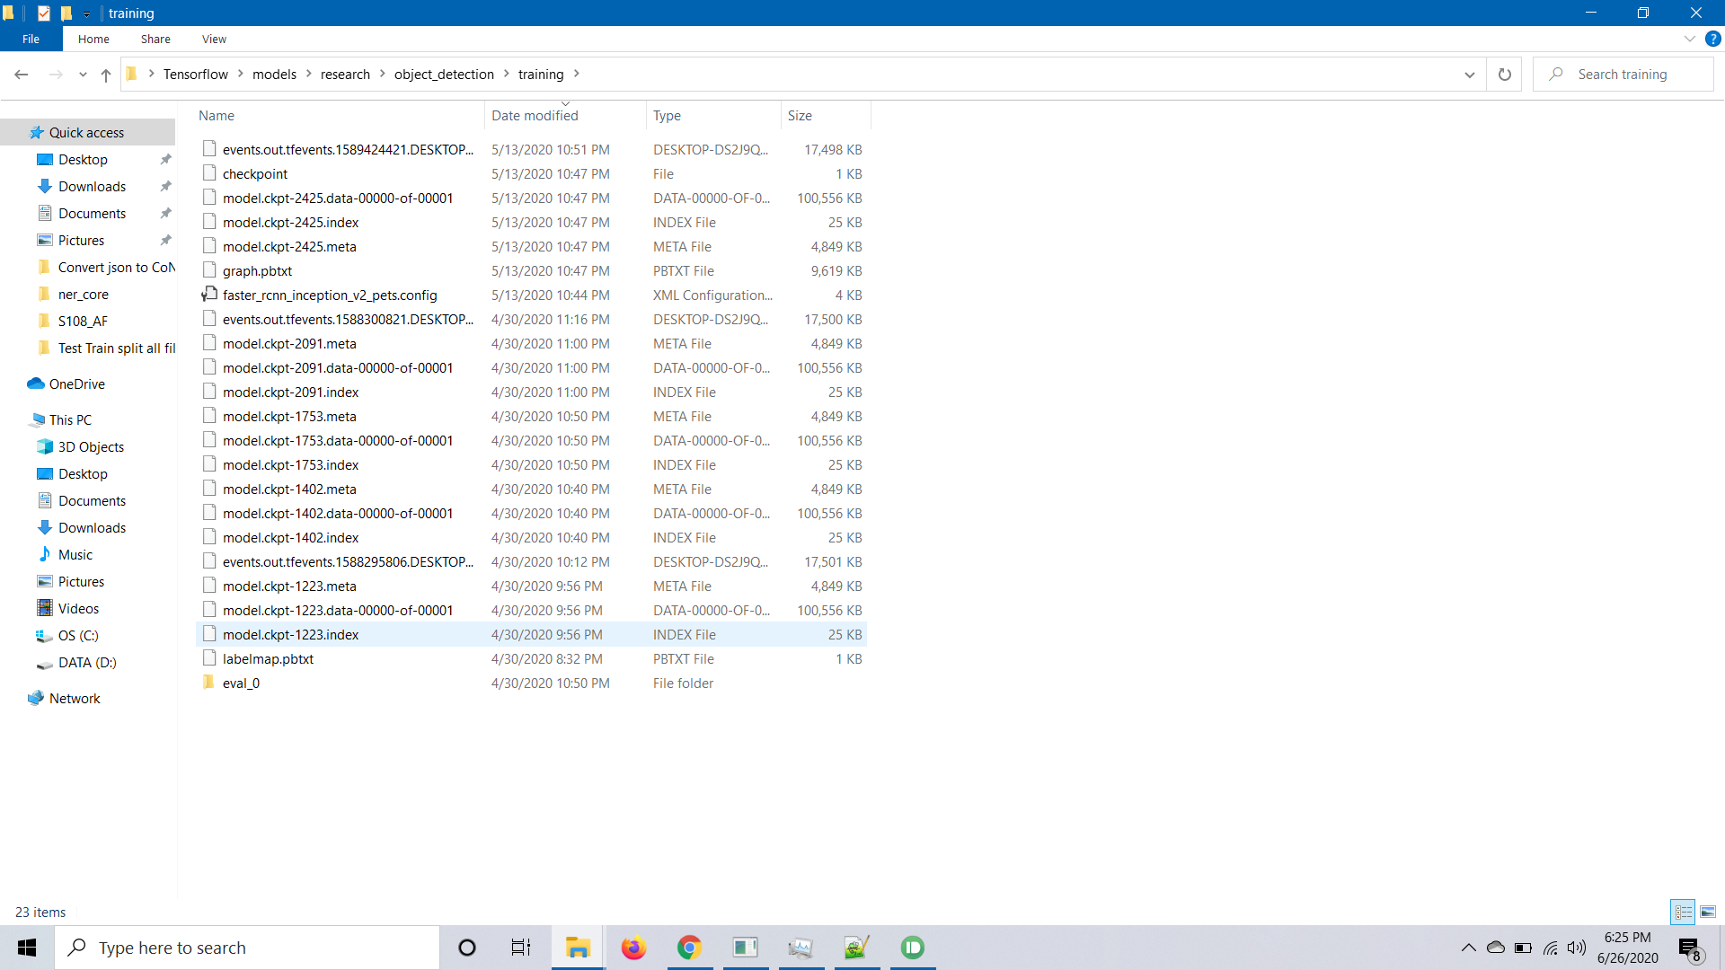
3. Place the jupyter notebook provided in the object detection folder and change the following fields.  
     
   Cell #4  
     
   MODEL_NAME = 'inference_graph’

PATH_TO_FROZEN_GRAPH = MODEL_NAME + '/frozen_inference_graph.pb'

PATH_TO_LABELS = 'training/labelmap.pbtxt'  
  
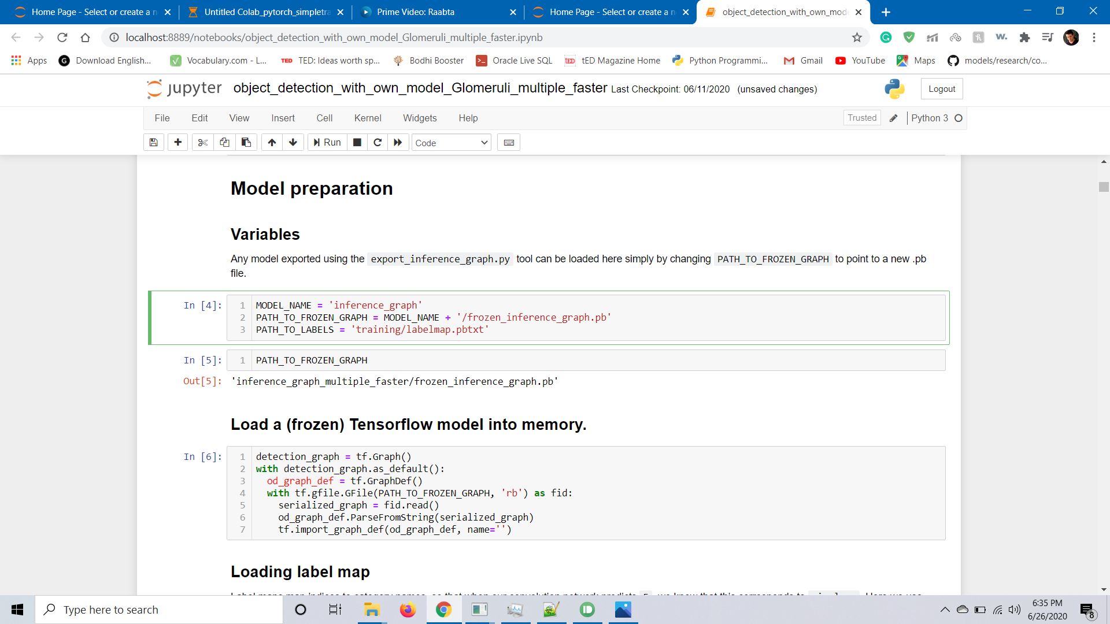  
  
Cell #30, give the path to the image to be tested.

